

**Project Report**

**Software Design Document**

– Hanoi, February 2024 –

**Table of Contents**

I. Record of Changes 3

II. Software Design Document 4

1. System Design 4

1.1 System Architecture 4

1.2 Package Diagram 4

1.3 Database Design 5

3. Detailed Design 7

3.1 <SubFeature/Function Name1> 7

3.2 <SubFeature/Function Name2> 8

4. Class Specifications 8

4.1 package_name1 8

# I. Record of Changes

|  |  |  |  |
| --- | --- | --- | --- |
| Date | A* M, D | In charge | Change Description |
|  |  |  |  |
|  |  |  |  |
|  |  |  |  |
|  |  |  |  |
|  |  |  |  |
|  |  |  |  |
|  |  |  |  |
|  |  |  |  |
|  |  |  |  |
|  |  |  |  |
|  |  |  |  |
|  |  |  |  |
|  |  |  |  |

*A - Added M - Modified D - Deleted

# II. Software Design Document

## 1. High Level Design

### 1.1 System Architecture

*[The content of this section includes the overall architectural diagram which includes the sub-systems and/or components, the external systems (if any), and the relationships (communication messages) among them. You need also provide the explanation for each of the diagram components (modules, sub-systems, external systems, etc.)].*

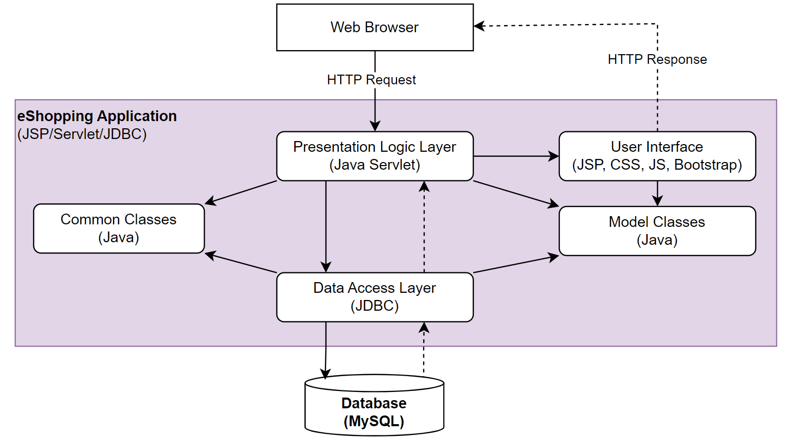

|  |  |  |
| --- | --- | --- |
| **No** | **System Component** | **Description** |
| *01* | *Web Browser* | *<Description of the component* ***Web Browser****>* |
| *02* | *User Interface* | *…* |
| *03* | *Presentation Logic Layer* |  |
| *04* | *…* |  |

### 1.2 Package Diagram

*[Provide the package diagram for each sub-system. The content of this section including the overall package diagram, the explanation, package and class naming conventions in each package. Please see the sample & description table format below]*

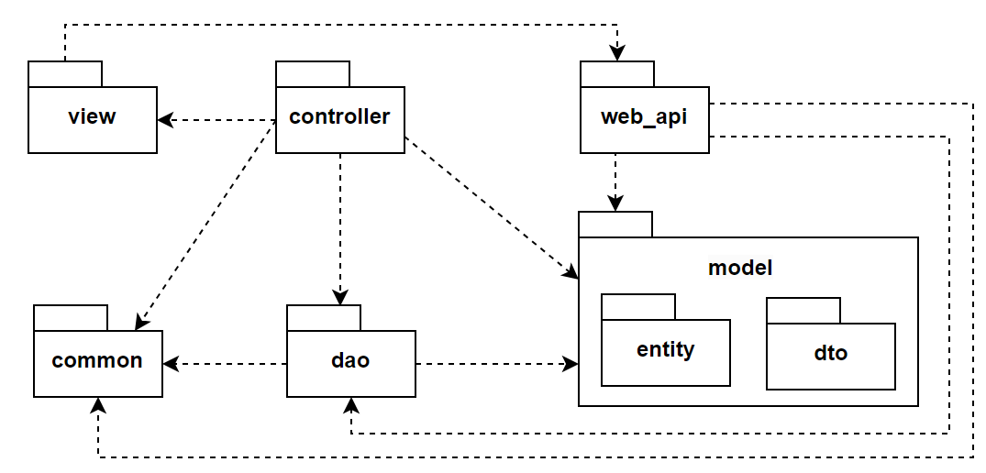

***Package descriptions***

|  |  |  |
| --- | --- | --- |
| **No** | **Package** | **Description** |
| *01* | *view* | *<Description/Purpose of the package* ***view****>* |
| *02* | *web_api* | *…* |
| *03* | *…* |  |

### 1.3 Database Design

*[Provide the files description, database table relationship & table descriptions like example below]*



#### 1.3.1 table_name1

*[Provide brief description of the table here]*

*[Provide the detailed table fields description using below table format*

|  |  |  |  |  |  |  |
| --- | --- | --- | --- | --- | --- | --- |
| **No** | **Field** | **PK** | **FK** | **UN** | **NN** | **Description** |
| *01* | *<field_name1>* |  |  |  |  | *<Description of the field_name1>* |
| *02* | *<field_name2>* |  |  |  |  | *…* |
| *..* |  |  |  |  |  |  |

*\* PK~Primary Key; FK~Foreign Key; UN~Unique; NN ~ not null*

*]*

#### 1.3.2 table_name2

…

## 2. Detailed Design

### 2.1 <SubFeature/Function Name1>

*[Provide the detailed design for the feature <Feature Name1>. It includes Class Diagram and Sequence Diagram(s);* ***For the features/functions with the same structure of class & sequence diagrams for all the use cases (UCs) of the SubFeature/Function****]*

#### 3.1.1 Class Diagram

*[This part presents the class diagram for the relevant feature, details of each class as provided in the section II.4]*

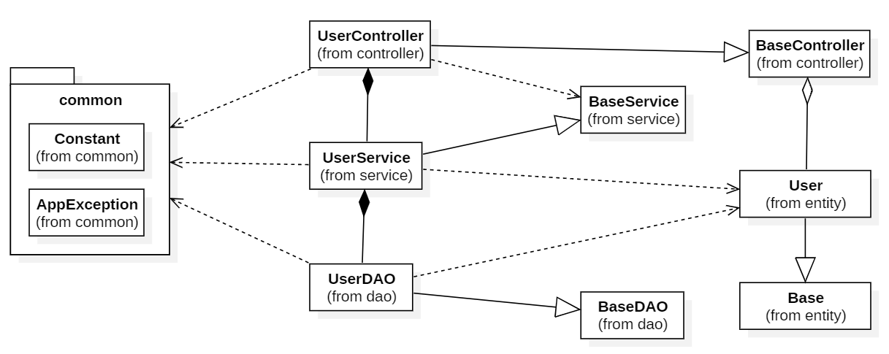

***3.1.2 <UC Name1>***

*[Provide the sequence diagram(s) for the feature, see the sample below]*

#### 3.1.3 <Sequence Diagram Name2>

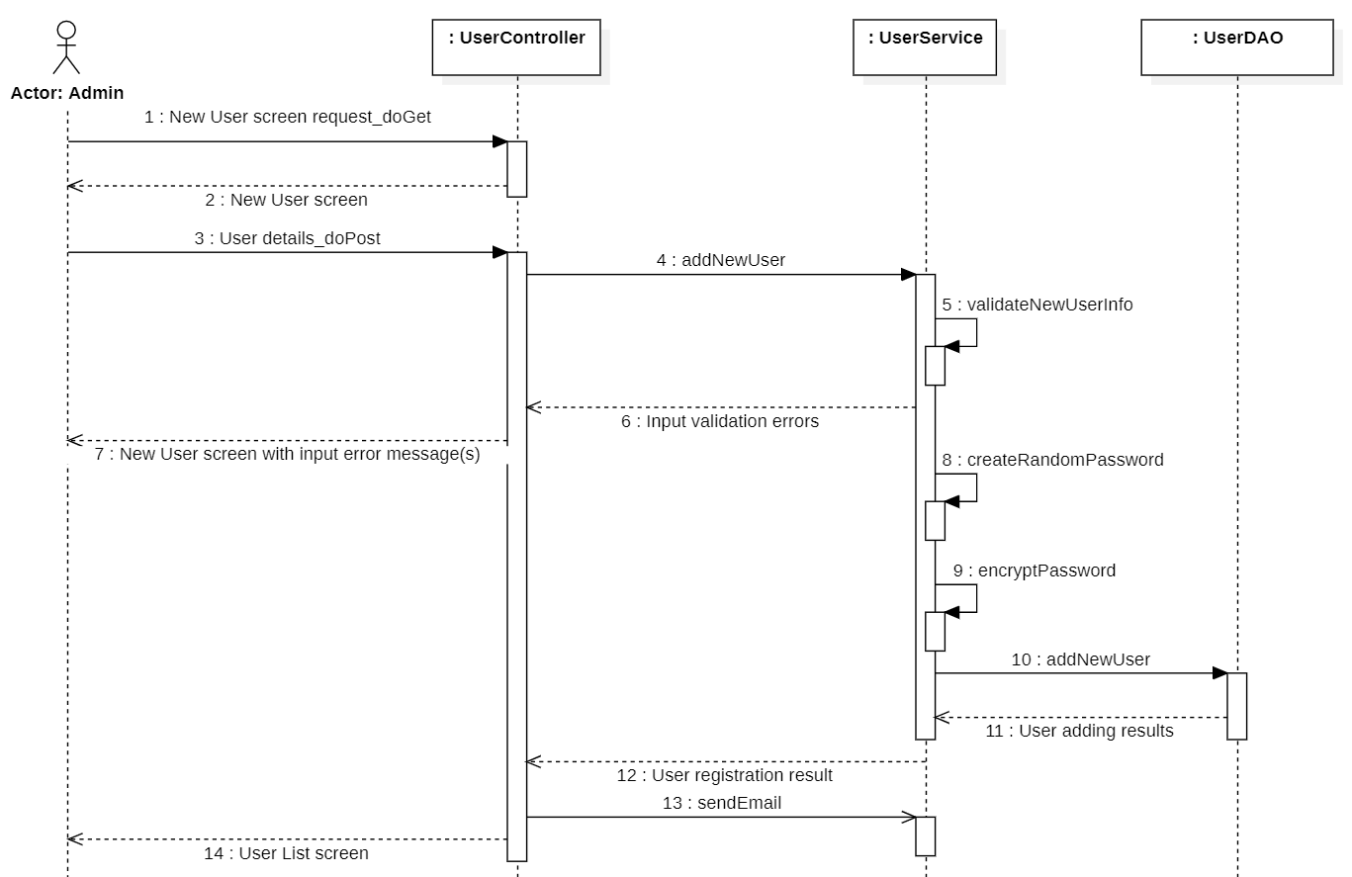

#### 3.1.4 …

### 2.2 <SubFeature/Function Name2>

…

## 3. Class Specifications

### 3.1 package_name1

This section provides the detailed specifications for the classes in the package package_name1

#### 3.1.1 ClassName1

*[Provide brief description of the class here]*

*[Provide the class attributes and operations using below table format*

|  |  |  |
| --- | --- | --- |
| **No** | **Name** | **Description** |
| ***Attributes*** | | |
| *01* | *<attributeName1>* | Visibility: *<attribute’s visibility: private, protected, default…>*  Type: *<data type of the attribute: int, String...>*  Purpose: *<description or purpose of the attribute>* |
| *02* | *<attributeName2>* | *…* |
| *..* |  |  |
| ***Methods/Operations*** | | |
| *01* | *<methodName1>* | Visibility: *<operation’s visibility: private, protected, default…>*  Return: *<void or return type of the operation: int, String,..>*  Purpose: *<description or purpose of the method>*  Parameters: *<<list out all the method parameters and provide details (name, data type, purpose/description) of each method parameter here*  *- paramName1:type1, purpose/description1*  *- paramName2:type2, purpose/description1*  *>>* |
| *02* | *<methodName2>* | *…* |
| *..* |  |  |

*]*

#### 3.1.2 ClassName2

…